BEEE EXPERIMENT

**Exp. 1** **Design automatic led Diwali lights (consisting of 6 led’s) such that it only works during night and can generate two patterns which can be toggled with switch. a. Pattern 1 –led chaser b. Pattern 2 – even-odd led’s**

**Apparatus** Arduino Board, LED , Resistance - 440ohm, Breadboard, photoresistor

**Theory**

In this Experiment, we used the concept of LED blinking where LED 1 should be turn ON and left LEDs turn OFF. Then LED 2 turn ON and left LEDs turn OFF. Again LED 3 turn ON. With each particular interval in milliseconds. Now we take 6 LEDs, 11 jumped wires, Arduino, Resistance, Breadboard,photoresistor and some lines of code. To Run our experiment.

Experiment learn about

1. LEDs
2. polarity where the positive side of LED should be longer leg and the negative side of LED should be shorter leg
3. More current gives more light in LEDs
4. Too much power will be destory our main hero which is LED so to save them form this tragic villian we used a sheild for him i.e Resistor. Resistor helps to overcome the power or current.



1. Arduino

In this device, we do not need to learn/observed all point. We need to focus on only.

1. Pins whose range from 0-13 and also know as digital pins.
2. GND - It is know as Ground. For making circuit closed.
3. LED light exist in the plate of Arduino and whenever LED start blinking its show hardware connection is right.

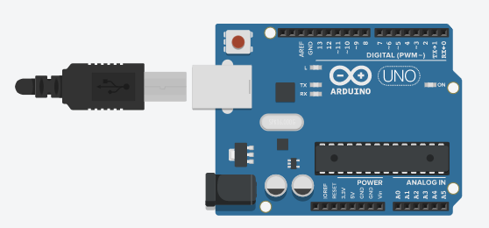

1. Resistance

In this device, we compulsory to use resistance to prevent our LEDs from fuse. Because it oppose the some extra kind of electricity to go in the LED.

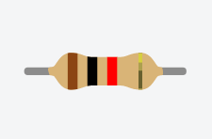

1. Breadboard

In this device, if we connect more than 2 connection without any soldering. We use Breadboard. It helps to make our connection neat and clean. It also no chance of break down connection as like occur in soldering as except it should be connection tight.

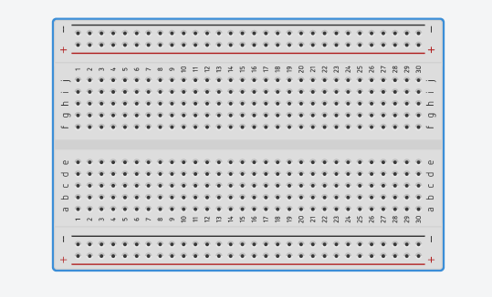

5.Photoelectric.

A **photoresistor** (or **light-dependent resistor**, **LDR**, or **photo-conductive cell**) is a light-controlled variable [resistor](https://en.wikipedia.org/wiki/Resistor). The [resistance](https://en.wikipedia.org/wiki/Electrical_resistance) of a photoresistor decreases with increasing incident light intensity; in other words, it exhibits [photoconductivity](https://en.wikipedia.org/wiki/Photoconductivity). A photoresistor can be applied in light-sensitive detector circuits, and light-activated and dark-activated switching circuits.

**Circuit Diagram**

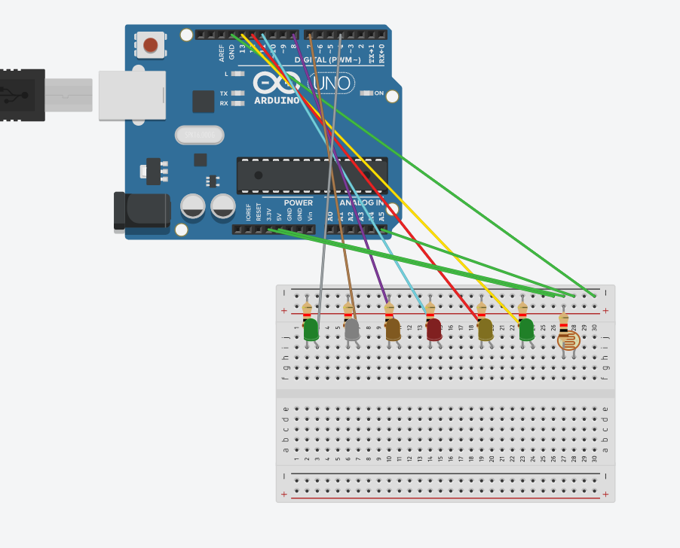

**Problem and Troubleshooting**

When we do this Experiment, we face some problems related from hardware and software also.

In Hardware connection, we did not know that polarity of LED connected in ground or digital pin. So in this situation we connect LED in the twice times for see that LED is glowing or not. Then after some connection we understand that negative polarity connected in the ground and positive polarity connected in pins. And one more problems occur in the hardware that is LEDs fuse. Physically we did not decide that LEDs is fused or not. So we check the LED in Arduino.

In software connection, we write some lines of code to run our program in such format. The problem, we faced in this i.e algebraically problems. For example - “PinMode” is a code word in code lines and it always written in this manner, not in small letters or not in capital letter and we were written in this form . And “digitalWrite” also create this type of problem. So In this situation we concentrate on coding and their words also.

**Precaution**

In this Experiment, we take some precaution in the Hardware connection. By no. Elements we use in this connection. We remember some things.

1. All the elements work accurately.
2. All the connection should be tight.
3. All the connection should seem neat and clean.
4. Keep Arduino safe and stable on the desk.
5. Never put water bottel on the Desk.
6. Connect the elements so and so safely, because elements must be crack down by some extra forces. So keep connecting lightly.

**Learning Outcomes**

In previously, We were talked about learning/observation points of experiment. But in this Experiment LED chaser tells us that we will make no. of format of LEDs by using Arduino and their code also. In this we will talk about skill or what we earned from this experiment.

For us earning point be the familiar from arduino. Last few days before we did this experiment we didn’t know about arduino.But now, **Arduino** boards are able to read inputs - light on a sensor, a finger on a button, or a Twitter message - and turn it into an output - activating a motor, turning on an LED, publishing something online. Arduino use for many more experiment like as LEDs flasher. And Arduino is just small computer or microprocessor to improve the quality of work.

That’s it NO ROCKET SCIENCE DID WE….. EASY PEASY….

**Thankyou**